Assignment-4

Create 2 branches 2026Q1 and 2026Q2 (Created 3 branches below) in github which are having index.html files. Jenkins master and 2 slave machines. whenever there are changes in index file on slave machines new container needs to be created and that index file needs to be deployed on that so that we can access the index file on browser.
(Use Volume here instead of docker cp command to copy index file)

- Jenkins master and slave machines
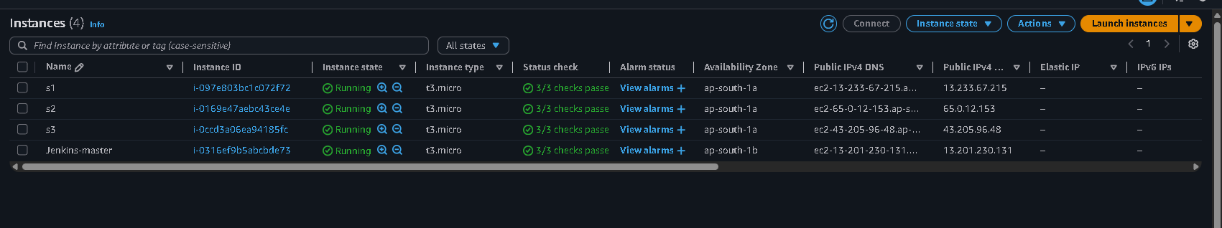

- GitHub branches
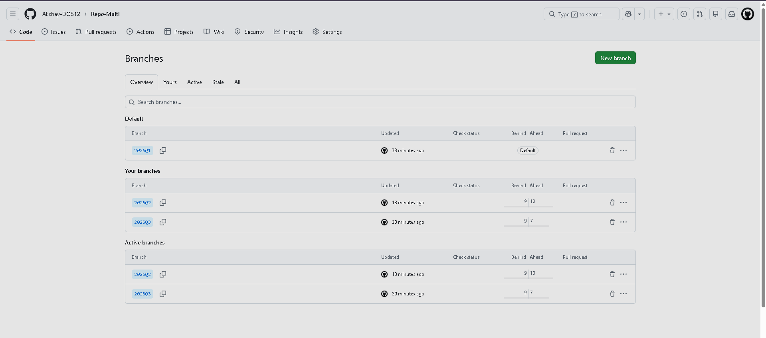

- Jenkins job script
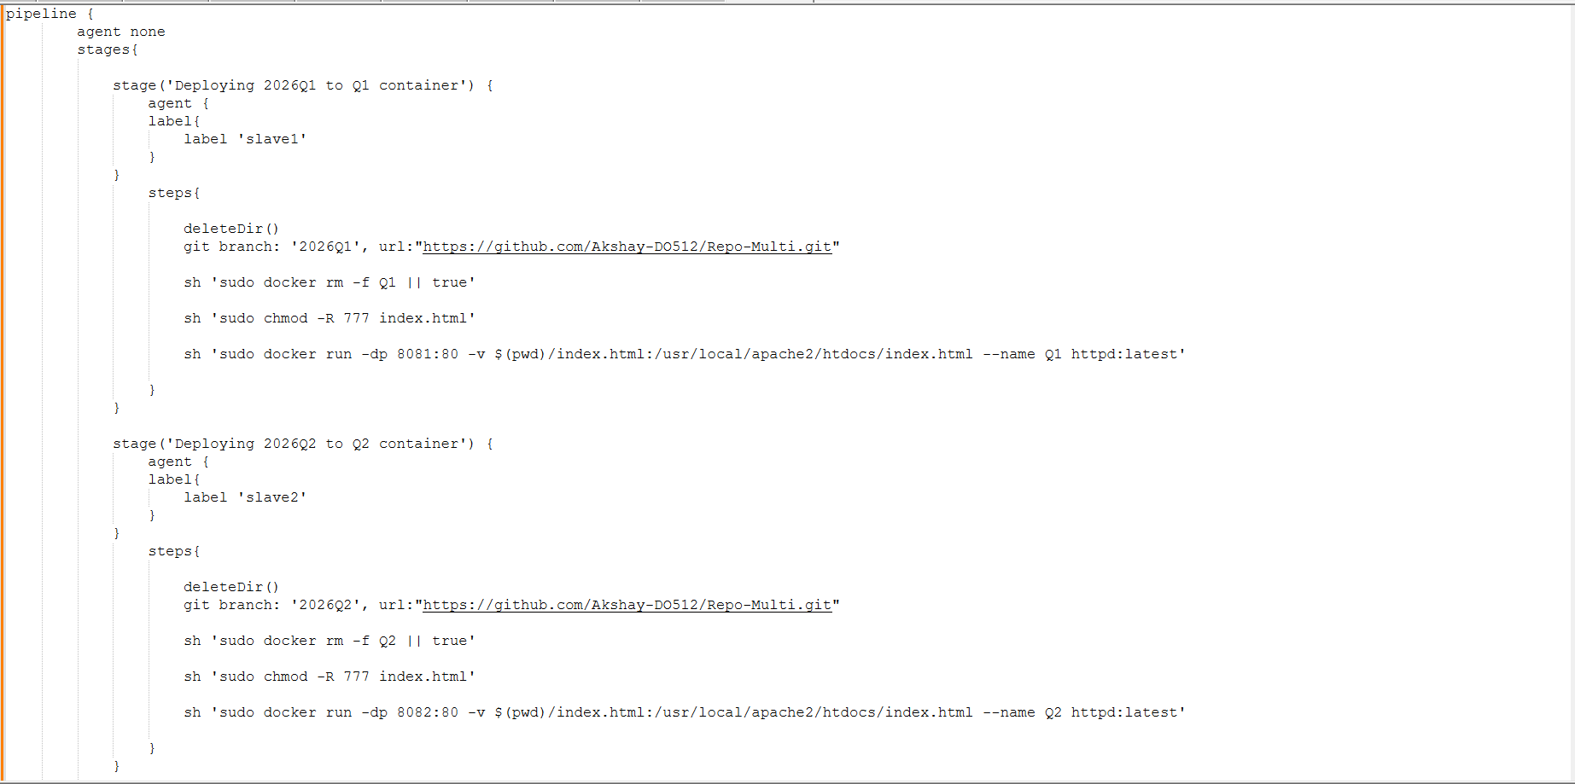
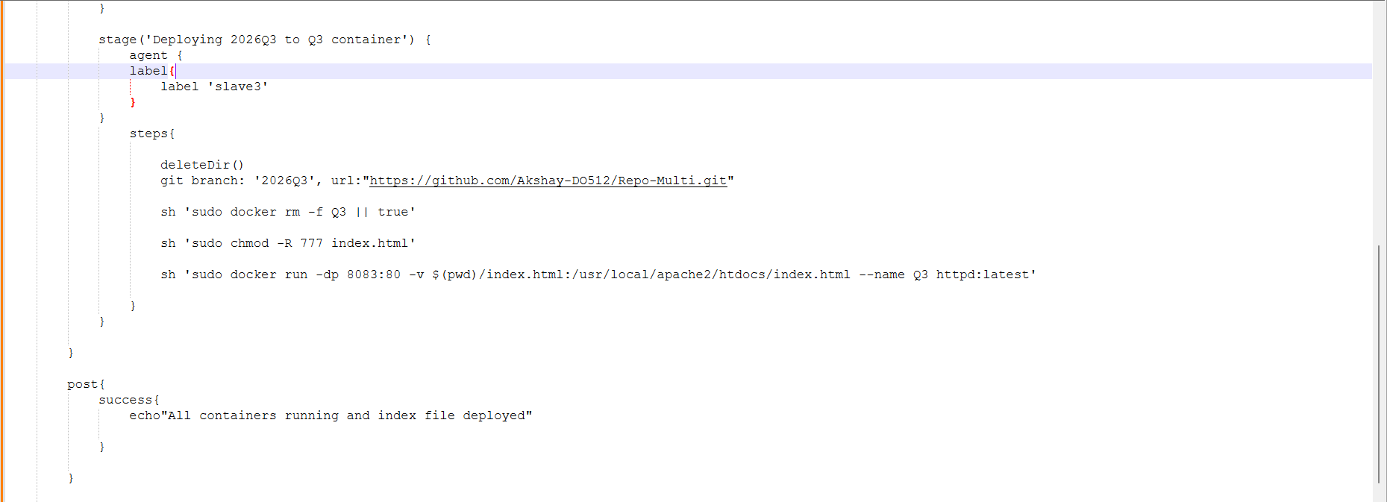

Output
Port:8081
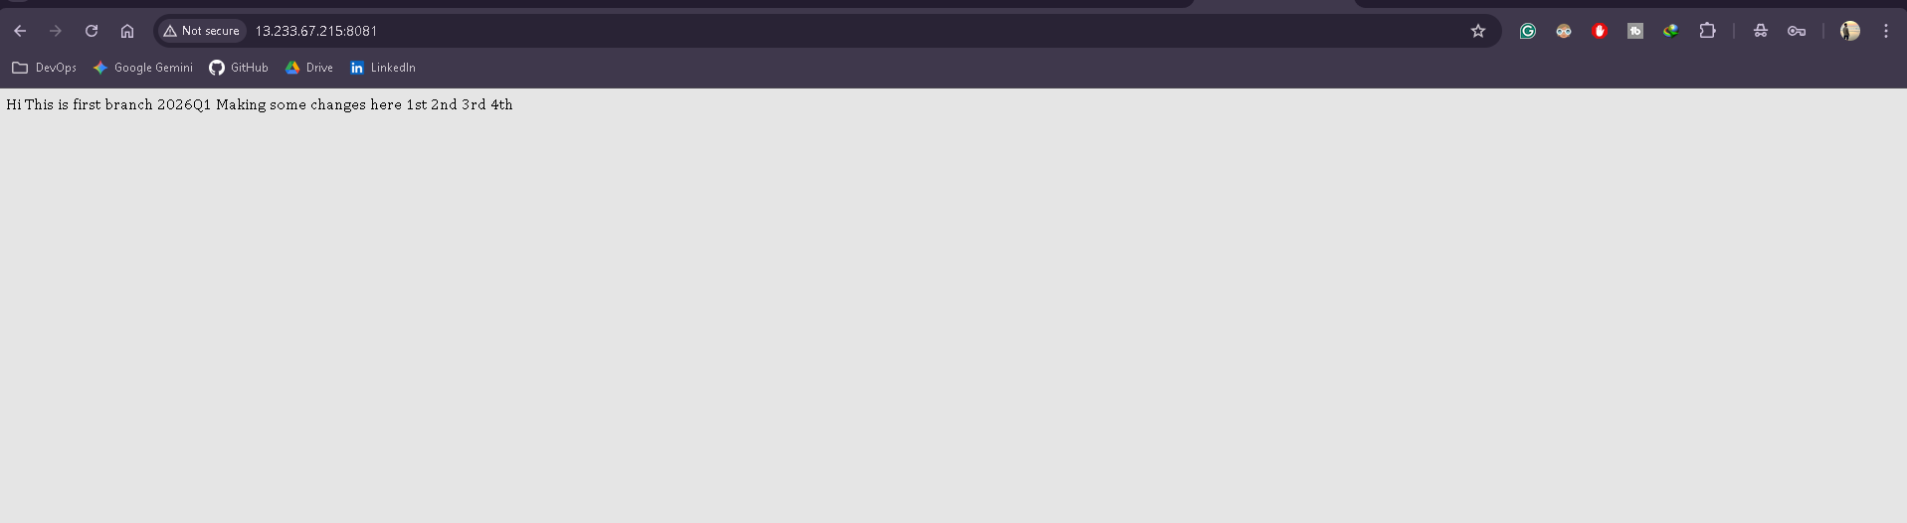

Port:8082
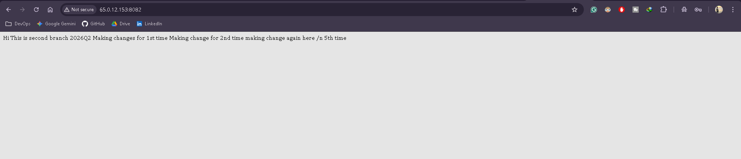

Port:8083
